User Interface

* Open ‘ECMTask.sln’ file in Visual Studio (2019 in this example)
* From the top menu select ‘Test’ -> ‘Test Explorer’
* Expand tree
* Select at least one test and right click on it
* Click ‘Run’

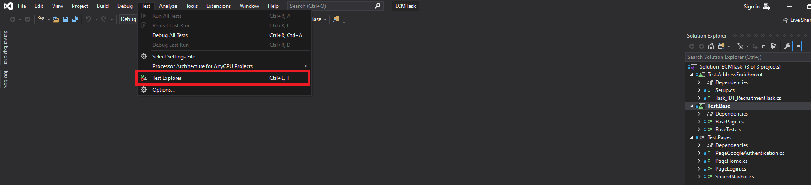

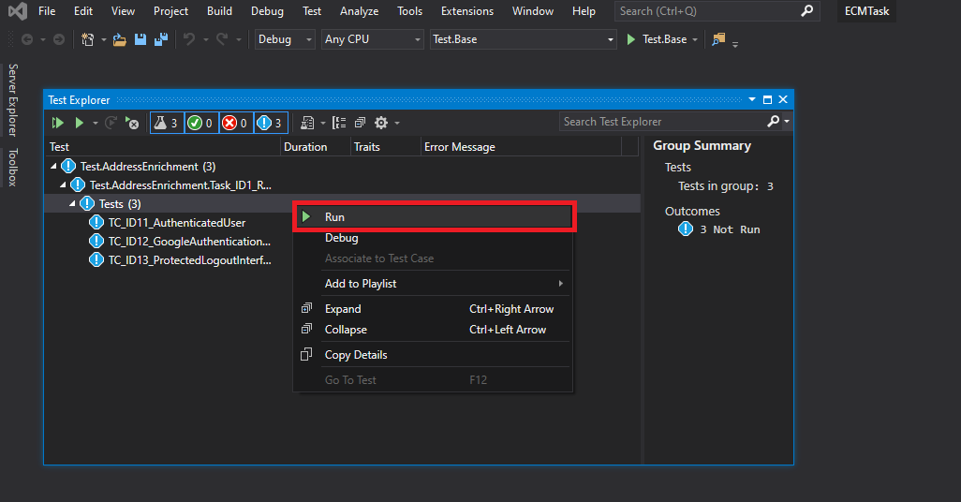

API

* Download Postman (<https://www.getpostman.com/downloads/>)
* Open Postman
* Click on the ‘Import’ button (top left corner)
* Choose collection file (Postman -> AddressEnrichment.postman_collection.json)
* Click ‘Runner’ button (top left corner)
* Select collection to run (AddressEnrichment)
* Click Run button

